VENANGO TECHNOLOGY CENTER
JOINT COMMITTEE
1 Vo-Tech Drive
Oil City, Pennsylvania 16301

MINUTES

October 4, 2021

The regular meeting of the Venango Technology Center Joint Committee was held this evening in the Conference Room of the Venango Technology Center, 1 Vo-Tech Drive, Oil City, PA 16301. Mr. Come called the meeting to order at seven o’clock (7:00) p.m.

Mr. Come asked the members to pause for a moment of silence.

Mr. Come asked the members to stand for the pledge of allegiance.

Roll Call: Present: Robert Blauser, Andy Boland, Don Judy, Shari Neely, Jeff Thomas (zoom),
Todd Carson, James Come

Absent: Mark Marterella, James Disque, Troy Johnston

Also Present: Mr. Mario Fontanazza, Mrs. Stephanie Keebler (zoom)

Mr. Come stated the Joint Committee members had received copies of the Minutes of the September 7, 2021 meeting in the mail. She asked if there were any additions, corrections or deletions.

Mr. Carson, seconded by Mr. Blauser, moved to approve the Minutes of the September 7, 2021 meeting as submitted.

Roll Call: Ayes: Robert Blauser, Andy Boland, Don Judy, Shari Neely, Jeff Thomas, Todd Carson,
James Come

Nayes: None, motion carried.

The Treasurer and Secretary’s Report as of 9/7/21 was submitted for information.

Mrs. Neely, seconded by Mr. Carson, moved to accept the Treasurer and Secretary’s Report as of 10/4/21 as submitted.

The motion was unanimously approved.

A list of bills from in the amount of $770,709.66 was presented for approval.

Mr. Carson, seconded by Mr. Blauser, moved to approve the list of bills as presented.

Roll Call: Ayes: Robert Blauser, Andy Boland, Don Judy, Shari Neely, Jeff Thomas, Todd Carson,
James Come

Nayes: None, motion carried.

Under Communications, Mr. Fontanazza discussed the Professional Advisory Committee. He also discussed the Calendar of Events for the month of September and the Monthly Enrollment Report as of 10/4/21 were submitted.

At 7:08 p. m. Mr. Come requested an executive session for personnel matters.

At 7:11 p. m. the meeting reconvened.

Mr. Come requested approval of the action items as presented. Item 8. a) i.- xi. in one motion.

Mr. Carson, seconded by Mr. Blauser, moved to approve action items 8. a) i.- xi. as follows:

- Approve Tuition increase of $300.00 for Practical Nursing for the 2022-2023 school year to
$15,750.00.
- Approve Ken Brannon as an Instructional Aide at a salary of $12,500.00 prorated based on
the number of days worked. Funding – Perkins
- Approve advertising for an instructional aide at an annual salary of $12,500.00.
- Approve transferring Linda Lander to a custodial position at an annual salary of $27,000.00
prorated based on the number of days worked. Retroactive to September 20, 2021. Funding
– ARP ESSER Grant
- Approve advertising for the Supervisor of Maintenance. The salary range will be $55,000.00
to $65,000.00 depending on the candidate’s experience.
- Accept resignation of Anthony Pierucci Auto Trades instructor effective September 30, 2021.
- Approve Jonathan Haag as Auto Trades instructor on step 1 of the collective bargaining
agreement prorated on the number of days worked.
- Approve contract with Alco Construction to assemble the Curvco structure at a cost not to
exceed $16,700.00.
- Approve Tammy Botts to attend the ACAPA conference.
- Approve board policy changes as presented.
- Approve list of equipment for disposal.

Roll Call: Ayes: Robert Blauser, Andy Boland, Don Judy, Shari Neely, Jeff Thomas, Todd Carson,
James Come

Nayes: None, motion carried.

Mr. Fontanazza reviewed his Issues/Activities for September 2021.

Mr. Come asked if there was any old business.

None was noted.

Mr. Come asked if there was any new business.

None was noted.

Upon motion by Mr. Carson, seconded by Mr. Blauser, the meeting adjourned at seven sixteen (7:16) p.m.

Recorded by
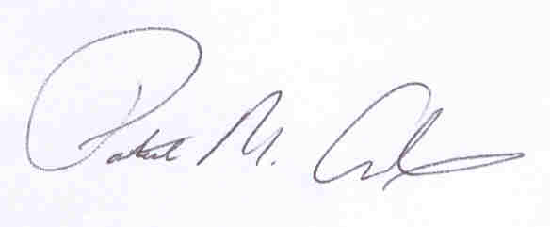
Patrick M. Adams
Secretary, Joint Committee

